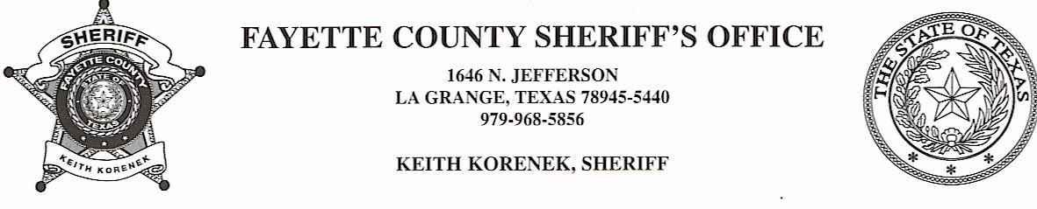

NOTICE OF ESTRAY AND IMPOUNDMENT

One brown cow with horns, no brands, tags or marking has been found running at large in Fayette County Texas, in the area of 2810 W. Old Lockhart Rd, Muldoon area, Fayette County, Texas. Pursuant to the stock laws of the State of Texas, Chapter Four, Title 121, Revised Civil Statutes of Texas 1925, said estray has been impounded. Impoundment is at the Flatonia Livestock Commission.

A diligent search has been conducted to locate the owner, to no avail. Notice is hereby given that, if the ownership of estray is not determined by the 9 th day of August, 2021, said estray will be sold at public auction/Sheriff’s sale at Flatonia Livestock Commission in Flatonia, Texas.

To claim affidavit of ownership, please contact Deputy Krenek with the Fayette County Sheriff’s Office at 979-968-5856.

Email to: webdev@cira.state.tx.us

